

|  |  |  |  |  |  |
| --- | --- | --- | --- | --- | --- |
| Programme | : | **B.Tech.** | Semester | : | **Fall 22-23** |
| Course | : | **CSE3002:**  **Internet and Web Programming Lab** | Slot | : | **L9+L10** |
| Faculty | : | **Dr. M. Premalatha** | Marks | : | **10** |

**Date: 20-08-2022**

Advait Deochakke

20BCE1143

**Exercise –4**

HTML – **Forms and CSS**

**Note:**

1. **View your registration number in the title bar and snap a screenshot of output along with the title bar.**
2. **Screenshot is required for every modifications of the web page.**

**CSS**

1. Write three sentences about your college life in VIT using a paragraph with division tag. Apply box model style to the div tag using internal CSS. The specification of the box model is given below.

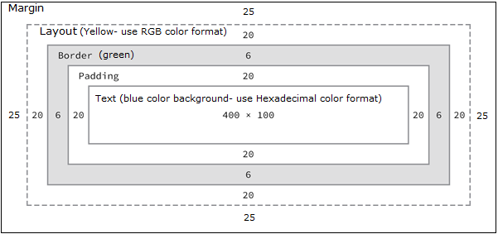

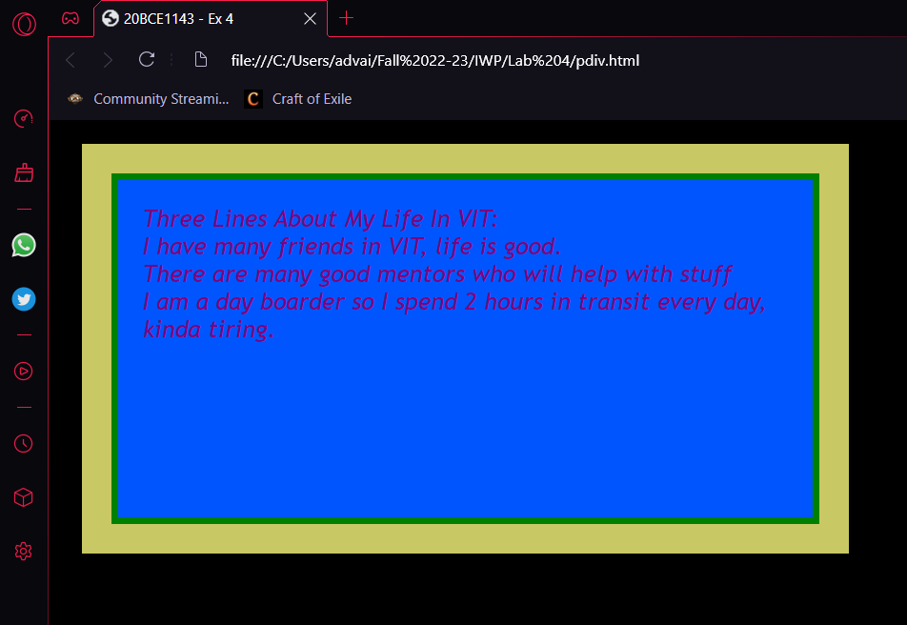

**Code:**

<head>

    <title>20BCE1143 - Ex 4</title>

    <style>

        div

        {

            width: 542px;

            height: 242px;

            border: 6px solid green;

            padding: 20px;

            margin: 45px;

            background-color: #05f;

            outline-width: 25px;

            outline-color: rgb(200, 200, 100);

            outline-style: solid;

        }

        body{

            background-color: black;

        }

        font{

            font-family: 'Trebuchet MS', 'Lucida Sans Unicode', 'Lucida Grande', 'Lucida Sans', Arial, sans-serif;

            font-size: 20px;

            font-weight: 500;

            font-style: italic;

            color: purple;

        }

    </style>

</head>

<body>

    <div>

        <font>Three Lines About My Life In VIT:<br>

        I have many friends in VIT, life is good.

        <br>There are many good mentors who will help with stuff<br>

        I am a day boarder so I spend 2 hours in transit every day, kinda tiring.</font>

    </div>

</body>

2. Include your favorite singer’s photo as an image. Add a video control to play any of his trending song. Add a CSS class named myphto that fulfils the following requirements:

* The image border is rounded, so that it appears as a circle.
* The image width and height are both 150px.
* The image has a solid border, has a width of 2px, and be colored black.
* Add title to the image and apply font change and color change animation effect. Use percentage to apply different colors and change font size.

For example, the image should look like Fig1:



Fig. 1. Photo



**Code:**

<head>

    <title>20BCE1143 - Ex 4</title>

    <link rel="stylesheet" type="text/css" href="myptho.css">

</head>

<body>

    <font>Song Name : Demon Dance Tokyo<br>Artist : Eve<br></font>

    <audio controls>

        <source src="C:\Users\advai\Music\da good stuff\E ve - Demon Dance Tokyo.mp3" type="audio/mpeg">

    </audio>

    <br>

    <font>The associated Youtube Music Video</font><br>

    <iframe width="480" height="270"

        src="https://www.youtube.com/embed/BLgqyQMjd5s">

    </iframe>

    <br>

    <font>Eve Image</font><br>

    <img src="C:\Users\advai\Fall 22-23\IWP\Lab 4\eve.jpeg">

</body>

**CSS:**

body{

    background-color:firebrick;

}

font{

    font-family: 'Trebuchet MS', 'Lucida Sans Unicode', 'Lucida Grande', 'Lucida Sans', Arial, sans-serif;

    font-size: 200%;

    font-weight: 500;

    color: transparent;

    animation: effect 1.25s linear infinite;

}

@keyframes effect {

    0% {

        background: linear-gradient(

                #00F00F, #FF0000);

        -webkit-background-clip: text;

    }

    25% {

        background: linear-gradient(

                #0F00F0, #FFF000);

        -webkit-background-clip: text;

    }

    50% {

        background: linear-gradient(

                #F00F00, #0FFF00);

        -webkit-background-clip: text;

    }

    75% {

        background: linear-gradient(

                #F0F000, #00FFF0);

        -webkit-background-clip: text;

    }

    100% {

        background: linear-gradient(

                #00F0F0, #000FFF);

        -webkit-background-clip: text;

    }

}

img{

    border-color: black;

    border-radius: 100px;

    border-style: solid;

    width: 150px;

    height: 150px

}

**JavaScript**

1. A General Service company hired you to calculate the labour cost and total charge for the services rendered to their client based on the formula given below:

Rate per hour : Rs.45/-

Labour cost : Rate per hour * hours work

Total Charge : Labour cost + Cost of Materials.

Write a JavaScript program (Internal) using suitable pop up boxes to read the necessary inputs and display the output.

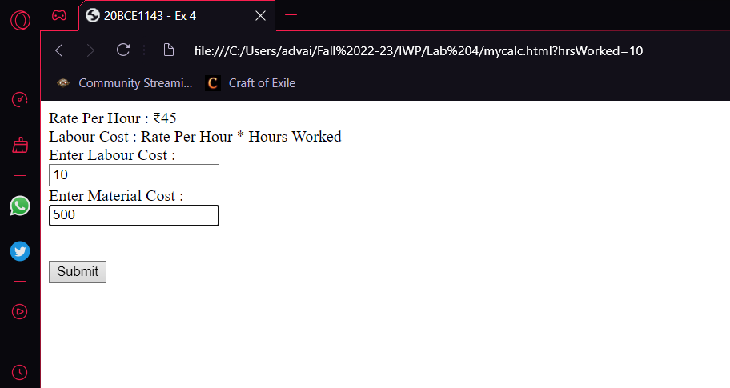

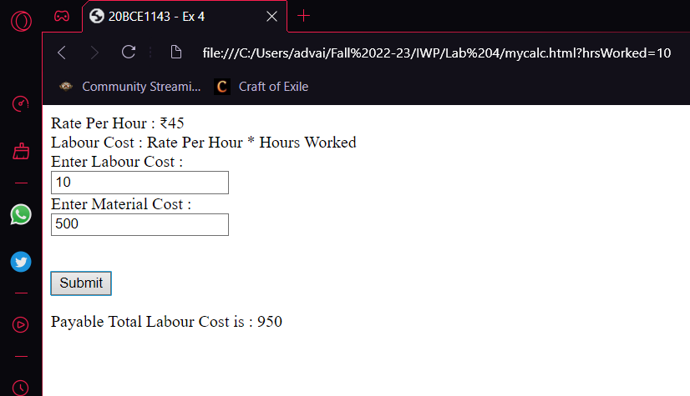

**Code:**

<head>

    <title>20BCE1143 - Ex 4</title>

</head>

<body>

    Rate Per Hour : ₹45<br>

    Labour Cost : Rate Per Hour * Hours Worked<br>

    Enter Labour Cost :

    <form id="myf">

        <input type="text" name="hrsWorked" value="Enter Number">

        <br>

        Enter Material Cost :<br>

        <input type="text" name="matCost" value="Enter Material Cost">

    </form><br>

    <button onclick="calc()">Submit</button>

    <p id="demo"></p>

    <script>

        function calc()

        {

            var x=document.getElementById("myf");

            var i=parseInt(x.elements[0].value)*45 + parseInt(x.elements[1].value);

            var text1="Payable Total Labour Cost is : "+i+"</br>";

            document.getElementById("demo").innerHTML=text1;

        }

    </script>

</body>

1. Write a JavaScript program that initializes a value for the variable ‘p’ and displays the prime numbers between 1 and the value initialized for ‘p’. The values should be printed in an HTML table.

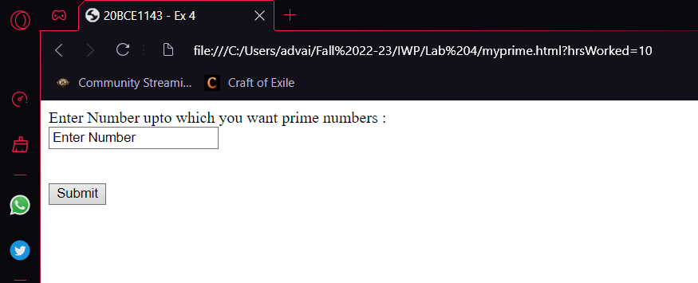

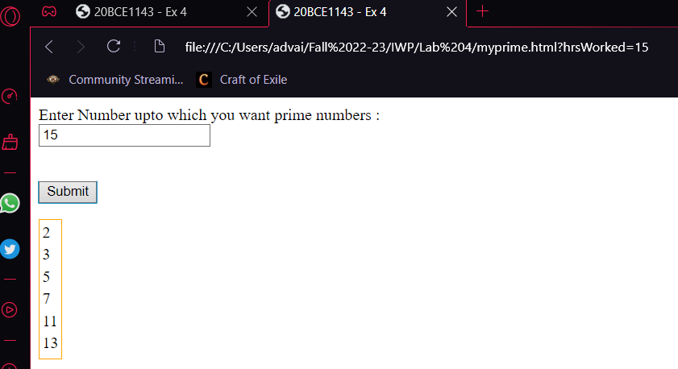

**Code:**

<head>

    <title>20BCE1143 - Ex 4</title>

</head>

<body>

    Enter Number upto which you want prime numbers :

    <form id="myf">

        <input type="text" name="hrsWorked" value="Enter Number">

        <br>

    </form><br>

    <button onclick="calc()">Submit</button>

    <p id="demo"></p>

    <script>

        function calc()

        {

            var op="<table style=\"border:orange 1px solid\"><tr><td>";

            var x=document.getElementById("myf");

            var i=parseInt(x.elements[0].value);

            for(var p=2; p<=i; p++)

            {

                var flag=0;

                for(var k=1; k<(p/2+1); k++)

                {

                    if(k==1)

                        continue;

                    if(p%k==0)

                    {

                        flag=1;

                        break;

                    }

                }

                if(!flag)

                op=op+p+"</td></tr><tr><td>";

            }

            op=op+"</table>";

            document.getElementById("demo").innerHTML=op+"<br>"

        }

    </script>

1. Write a JavaScript program to accept your reg.no and display it as shown below by applying inline style (2 marks)



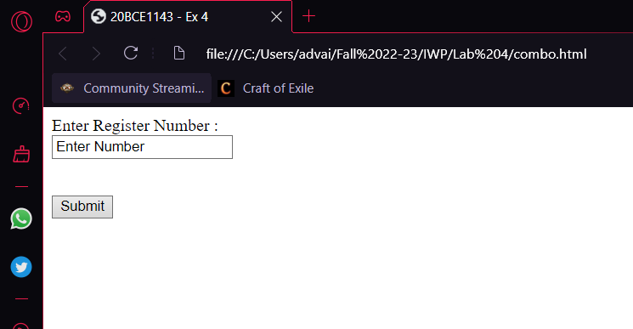

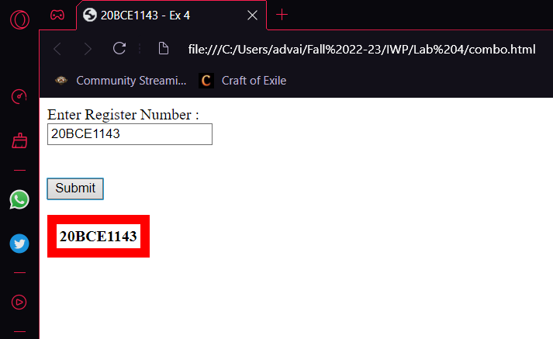

**Code:**

<head>

    <title>20BCE1143 - Ex 4</title>

</head>

<body>

    Enter Register Number :

    <form id="myf">

        <input type="text" name="hrsWorked" value="Enter Number">

        <br>

    </form><br>

    <button onclick="calc()">Submit</button>

    <p id="demo"></p>

    <script>

        function calc()

        {

            var p="<table style=\"border:red 10px solid\"><tr><td><b>"+document.getElementById("myf").elements[0].value+"</b></td></tr></table>";

            document.getElementById("demo").innerHTML=p;

        }

    </script>

</body>